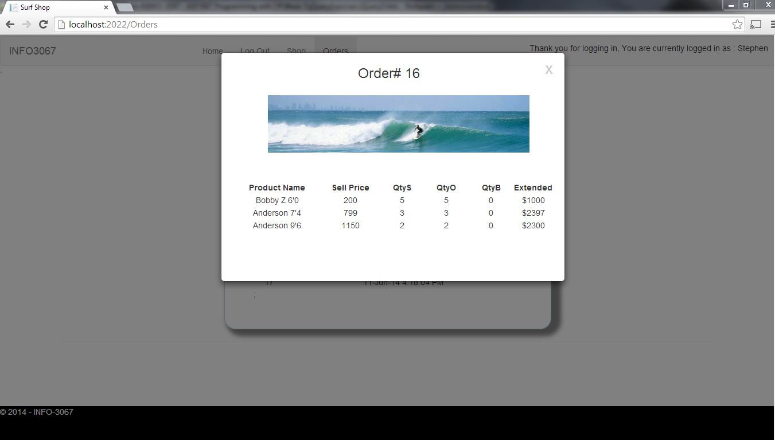

Screenshot

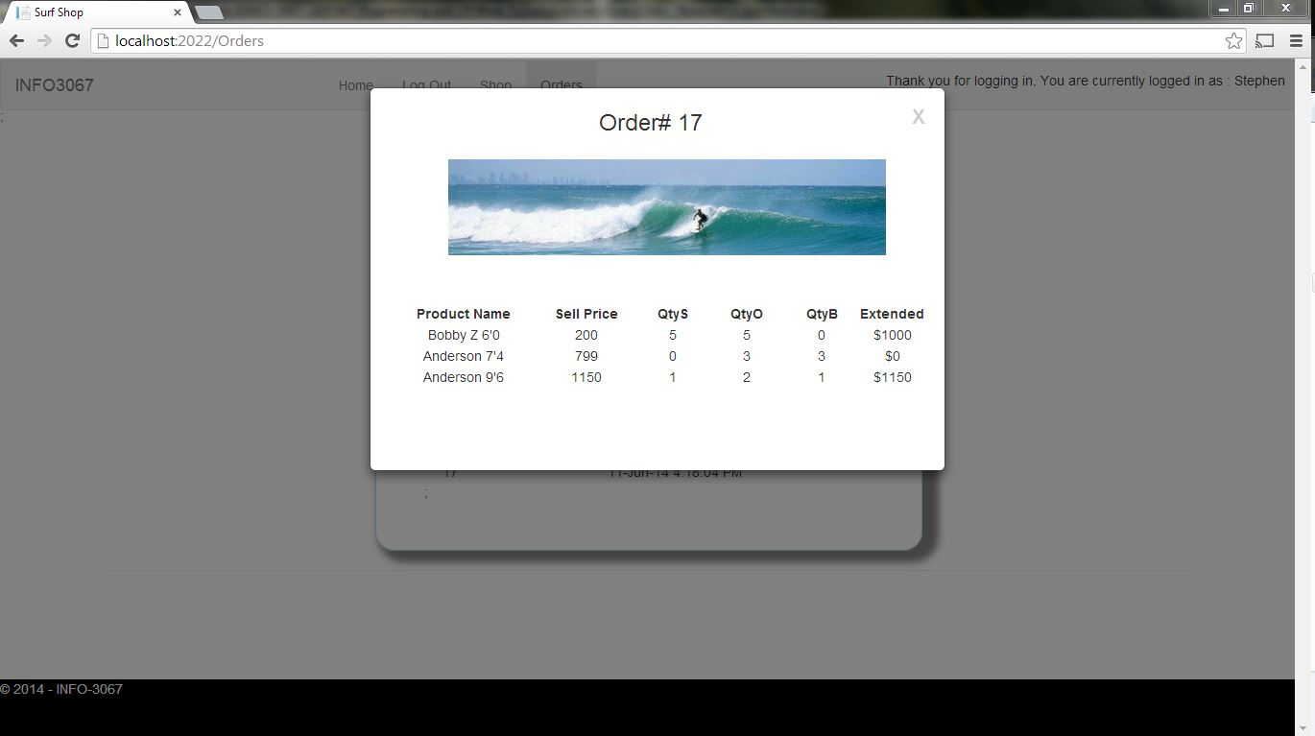

Screenshot

//Data Members

var popupTbl;

var oldElem

var noteNo = 0;

var myWindow;

var oldRow;

var oldClass;

var oid;

var orderDate;

var allOrders;

var data;

// Get Orders

function getOrders(oid, allOrders) {

if (allOrders == null) // Go only to the server once

{

$.getJSON("api/orderrest/" + $("#customer").val(), null, function (data, status, jqXHR) {

buildOrder(oid, orderDate, data); // call is asynchronous, so build in if

allOrders = data; // before loading global data for else

}).error(function (jqXHR, textStatus, errorThrown) //problem

{

console.log("ERROR" + textStatus + " - " + errorThrown);

});

}

else {

buildOrder(oid, orderDate, allOrders);

}

}

// Click Function

$('td').click(function () {

// if we have more than 1 table, we want the right one

if ($(this).attr('id') == 'OrderNo') {

//Populate

oid = $(this).text();

//Show Model

jQuery.noConflict();

$("#popup").modal("show")

$('#PopupBanner').text("Order# " + oid);

//Remove old table

if (oldRow != null) {

oldRow.removeAttr("style");

oldRow.removeAttr("class");

$(oldRow).toggleClass("itemSelected");

$(oldRow).toggleClass(oldClass);

}

oldRow = $(this).parents("tr");

oldClass = oldRow.attr("class");

oldRow.removeAttr("style");

oldRow.removeAttr("class");

oldRow.toggleClass("itemSelected");

cellContents = $(this).html();

//Build Order

getOrders(oid, allOrders);

}

});

// Build the Order Table

function buildOrder(oid, orderDate, allOrders) {

//Build the Table

var tbl = $('<table>');

// delete rows from old table (if it exists)

$(tbl).find("tr").remove();

/\* Row \*/

var tr = $("<tr>");

tr.html('<div style="text-align: left;">This is a Detailed List of Order# ' + oid + '</div></br>');

tr.appendTo(tbl); // add row to table

/\* Row \*/

tr = $("<tr>");

tr.html('<td style="width:30%;text-align:center;" class="tblItemHead"><b>Product Name</b></td>' +

'<td style="width:20%;text-align:center;" class="tblItemHead"><b>Sell Price</b></td>' +

'<td style="width:10%;text-align:center;" class="tblItemHead"><b>QtyS</b></td>' +

'<td style="width:10%;text-align:center;" class="tblItemHead"><b>QtyO</b></td>' +

'<td style="width:10%;text-align:center;" class="tblItemHead"><b>QtyB</b></td>' +

'<td style="width:15%;text-align:center;" class="tblItemHead"><b>Extended</b></td>');

tr.appendTo(tbl); // add row to table

tr = $("<tr>").addClass("itemData");

//Search Entire Orders Collection

$.each(allOrders, function (itemNumber, order) {

//Search Specific OrderItem Purchased

if (order.OrderID == oid) {

$.each(order, function (heading, info) {

tr.html('<td style="width:15%;text-align:center">' + order.ProductName + '</td>' +

'<td style="width:15%;text-align:center">' + order.SellingPrice + '</td>' +

'<td style="width:15%;text-align:center">' + order.QtySold + '</td>' +

'<td style="width:15%;text-align:center">' + order.QtyOrdered + '</td>' +

'<td style="width:15%;text-align:center">' + order.QtyBackOrdered + '</td>' +

'<td style="width:50%;text-align:center">$' + order.SellingPrice \* order.QtySold + '</td>');

tr.appendTo(tbl); // add row to table

$("#DateOfOrder").text("Date: " + order.OrderDate);

});

tr = $("<tr>");

}

});//end each

$('#popupTbl').find("tr").remove(); // clean out old stuff

$('#popupTbl').append($(tbl).html()); // put in new stuff

}//End Build